**Week 10**

**Large datasets:**

-Stochastic Gradient Descent

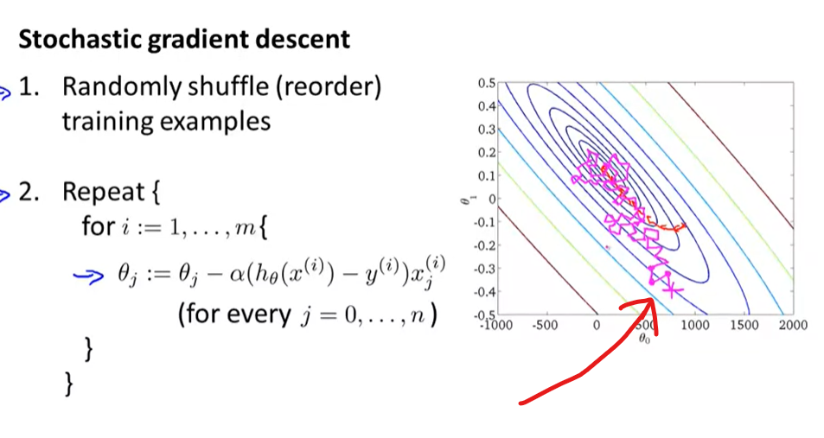

Convergence of SGD check

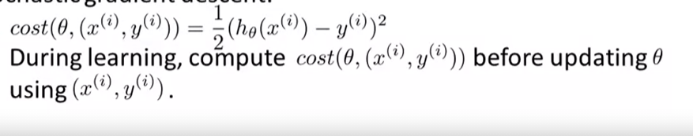



(or 5000 iterations)

Plot to check

Slowly decrease learning reate alpha.

-Mini-batch Gradient Descent

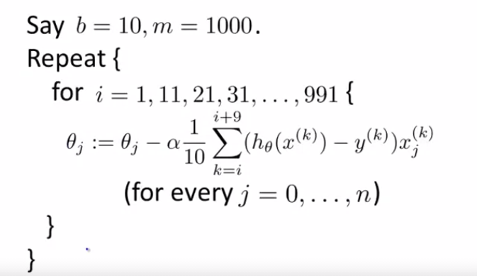

**Online Learning**

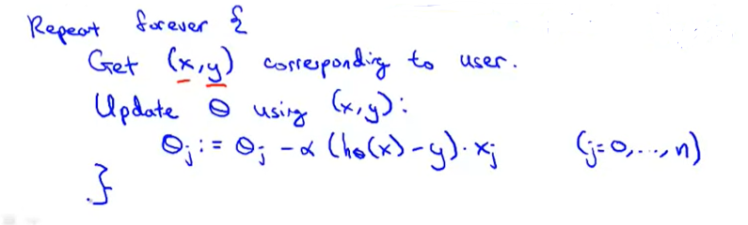

Get data online from user. Feed to algorithm then throw away. Don’t save data.

**Map Reduce**

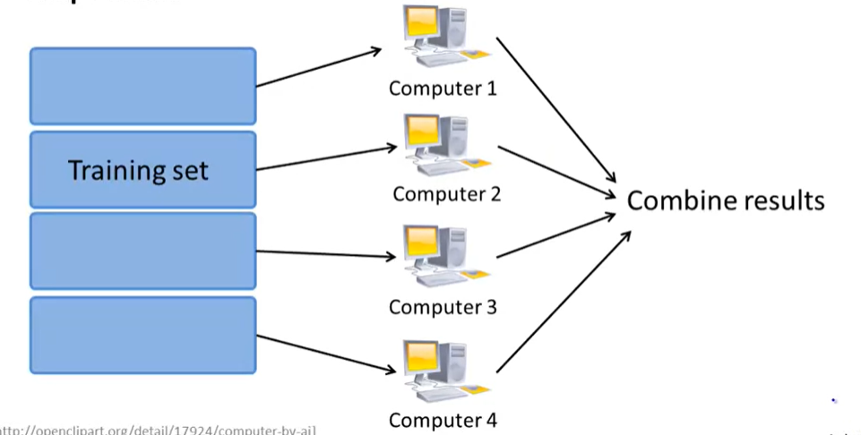

We can split training set. Use multi computer or multi core to train.